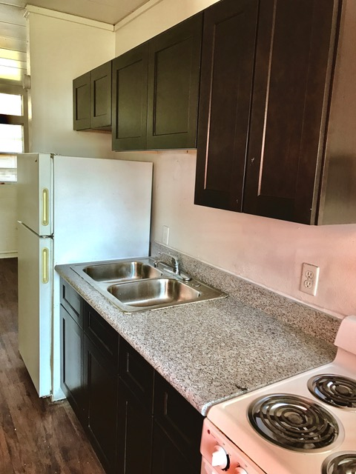 | 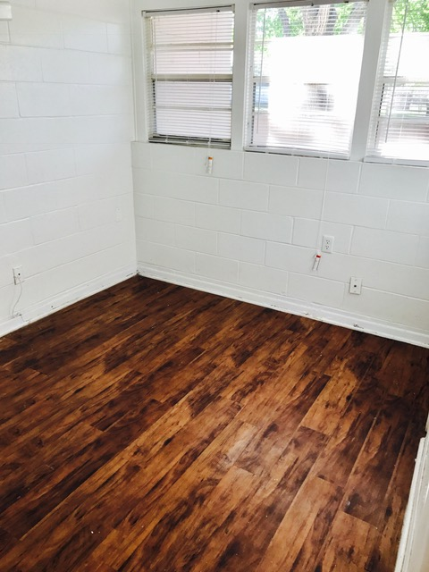
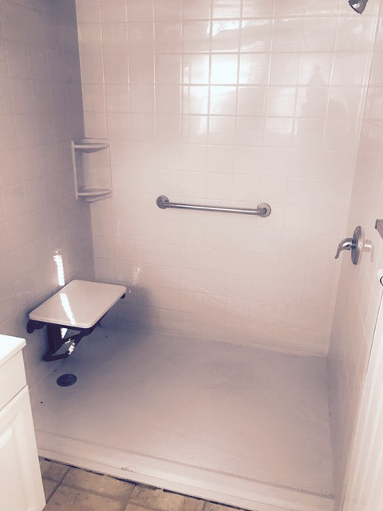 | 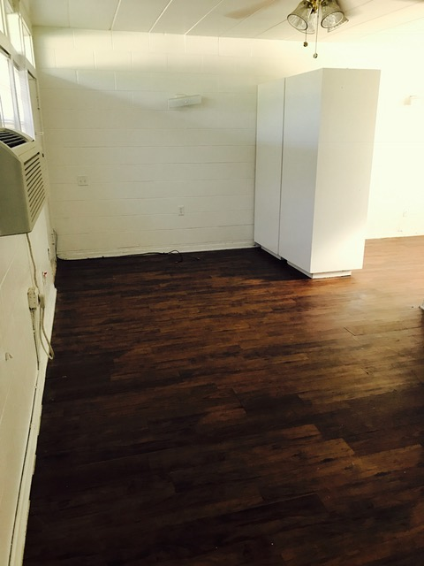

- Laminate Flooring
- Walk-In Shower
- Handicap Accessible
- Open Floor plan
- On-Site Laundry Facility
- Granite Counter Tops
- Spacious Patio Area
- Frost Free Refrigerator
- Ceiling Fans
- Covered Bus Pick-Up

